Moorhead Police Department
FACT SHEET

NOTIFICATION OF RELEASE IN MINNESOTA

RISK LEVEL THREE In addition to level two notification (schools and daycares as well as establishments and organizations that primarily serve individuals likely to be victimized by the offender), law enforcement may notify other members of the community whom the offender is likely to encounter.

The Moorhead Police Department is available to provide you with useful information on personal safety. The Moorhead Police Department may be reached at (218) 299-5120. To report criminal activity by this offender or any other individu al, please call 911.
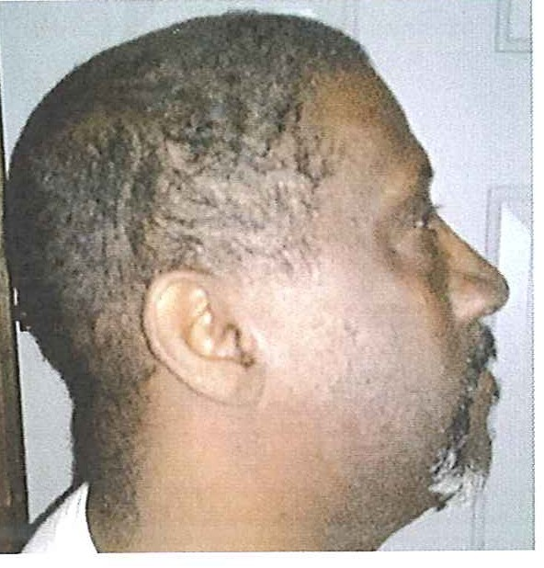

DANNY FITZGERALD COLEMAN DOB: 11/28/1964
OID: 213088

Race: Black Hispanic: No
Heig ht: 5'06" Eyes: Brown
Weight: 255 lbs. Hair: Black Complexion: Medium brown Build: Large

Registration statute(s): 609.342
Investigating agency: Moorhead Police Department

Release date: 07/15/2013 12/14/2015 12/14/2015

Supervision agent: Justin Ball at 218-846-8329

Offender engaged in sexual contact with a 13 year-old female victim. Contact included penetration. Offender gained access to victim after knocking at her residence. Force and threats were used to gain compliance. Offender was not known to victim.

Addr ess: I 000 block of I 8th Street South , Moorhead, MN 56560 Date of address change: 02/07/2014

The Moorhead Police Department is releasing this information pursuant to Minnesota Statutes 244.052. This statute authorizes law enforcement agencies to inform the public of a sexual or predatory offender 's release from prison or a secure treatment facility when the Moorhead Police Department believes that the release of information will enhance public safety and protection.

The individual who appears on this notification ha s been convicted of Criminal Sexual Conduct or another offense that requires registration with law enforcement pursuant to Minnesota Statutes 243.166 or 243.167.

This offender is not wanted by the police at this time and has served the sentence imposed on him/her by the court. This notification is not intended to increase fear in the commun ity. Law enforcement believes that an informed public is a safer public.

The Moorhead Police Department may NOT direct where the offender does or does not reside, nor can this agency direct where he/she works or goes to school. The risk level of this offender has been determined based largely on his/her potential to re-offend based on his/her previous criminal behavior.

Convicted sexual and predatory offenders have always been released to live in our communities. It was not until the passage of the Registration Act that law enforcement had an ability track the movement of these offenders after their initial release. With the passage of the Community Notification Act law enforcement may now share information about many of these offenders with the pub li c. Abuse of this information to threaten, harass or intimidate a registered offender is unacceptable and such acts could be charged as a crime. Such abuses could potentially end the ability of law enforcement to provide these notifications. If community notification ends the only person who wins is the offender. Many of these offenders derive their power from the opportunity that secrecy provides.

For questions about sex offenders and community notification, go to www.doc.state.nrn.us and click on " Level Three Predatory Offender Information"

form revised 09-10-2009

