  7/10/2019
  Moorhead Police Department
Fact Sheet
NOTIFICATION OF RELEASE IN MINNESOTA

  RISK LEVEL THREE
  In addition to level two notification (schools and daycares as well as establishments and organizations that primarily serve individuals likely to be victimized by the registrant), law enforcement may notify other members of the community whom the registrant is likely to encounter.
  The Moorhead Police Department is available to provide you with useful information on personal safety. The Moorhead Police Department may be reached at 218-299-5120. To report criminal activity by this registrant or any other individual, please call 911.
  RICHARD FOLDEN
 |  |  |  |  |  | 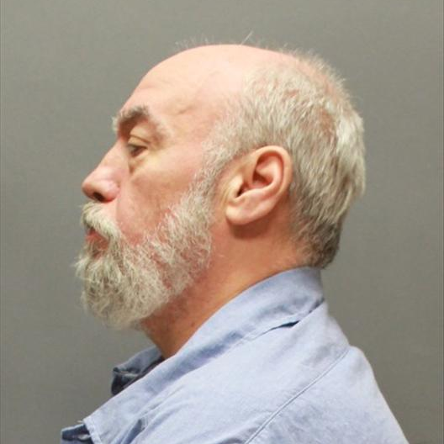
  06/12/2019
  04/01/2019

  DOB:
  05/07/1957
  OID:
  109399
  Race:
  White
  Height: 5' 7"
  Eyes: Brown
  Weight: 278 lbs.
  Hair: Gray
  Complexion: Medium
  Build: Medium
  Registration Statute(s): 609.342
  Investigating Agency: Moorhead Police Department
  Release Date: 07/22/2019
  Supervision Agent: Justin Ball (218) 846-8329
  Offense: Folden has a history of engaging in sexual contact with known female children and teens. Contact included penetration. Folden used threats to gain compliance in one instance.
  Address: Vicinity of 1st Avenue South and 21st Street South, Moorhead, MN 56560
  Date of Address Change: 07/22/2019
The Moorhead Police Department is releasing this information pursuant to Minnesota Statutes 244.052 and 253D. This statute authorizes law enforcement agencies to inform communities of a public registrant’s release from prison or a secure treatment facility when the Moorhead Police Department believes that the release of information will enhance public safety and protection.
The individual who appears on this notification has been convicted of Criminal Sexual Conduct or another offense that requires registration with law enforcement pursuant to Minnesota Statues 243.166 or 243.167.
This individual has served the sentence imposed on them by the court and is transitioning into the community. This notification is not intended to increase fear but rather raise awareness. Law enforcement believes that an informed public is a safer public.
The Moorhead Police Department may not direct where this individual does or does not reside, nor can this agency direct where they work or go to school.
Convicted sexual and predatory individuals have always been released to live in our communities. It was not until the passage of the Registration Act that law enforcement had an ability to track movement of these individuals after their initial release. With the passage of the Community Notification Act law enforcement may now share information about many of these individuals with the public. Abuse of this information to threaten, harass or intimidate a registered person is unacceptable and such acts could be charged as a crime. Such abuses could potentially end the ability of law enforcement to provide these notifications.

