Moorhead Library
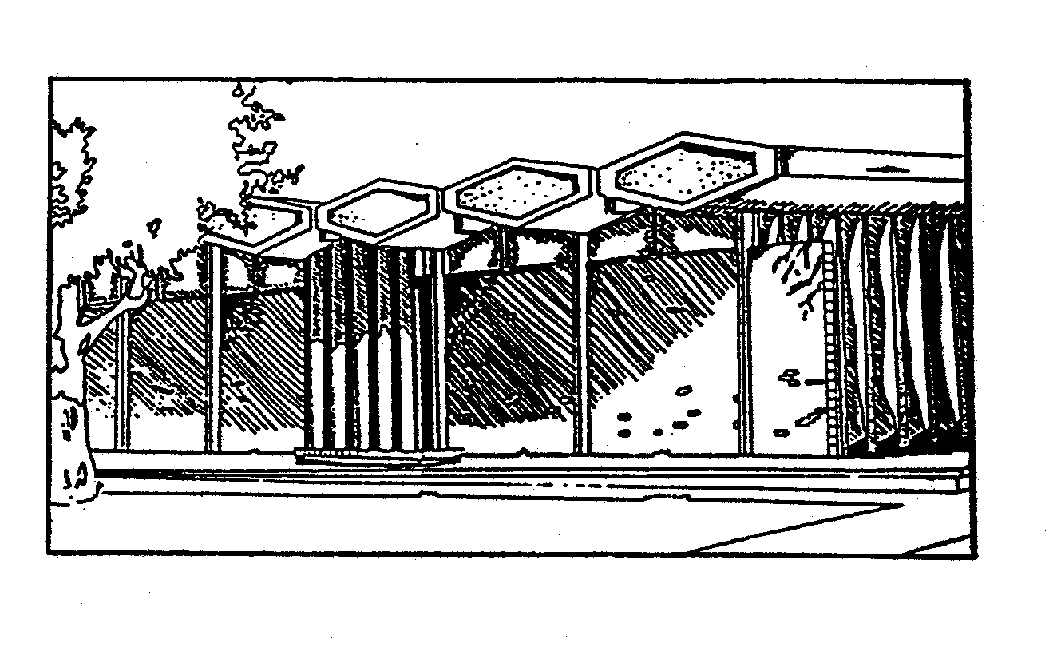
. . . Library Service at Its Best

BOARD OF TRUSTEES

Regular Meeting, January 14, 2014
Library Meeting Room (lower level), 5:30 p.m.

Agenda
1. Open Meeting
2. Approve Agenda
3. Approve minutes from September 10th meeting.
4. Public Comment
5. Meet the Library Staff – Cori Edgerton, Library Associate
6. LARL Report – LARL Board Members
7. Director’s Report – Megan (Handout)
8. Policy/Product Review - New LARL Website
9. Building Issues – See report
10. Other Business
11. Next Meeting - February 11th. See full meeting schedule for 2014 (Handout)
12. Adjourn
Moorhead Library is a Branch of Lake Agassiz Regional Library
118 5th Street South
Moorhead, MN 56560
218-233-7594
FAX: 218-236-7405

