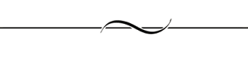
Groundbreaking
Clay County Campus

MAY
9
2017
Ceremony at 11:00 a.m.
“911” 11th St N
Moorhead, MN
(North of Courthouse)

Clay County Correctional Facility Joint Law Enforcement Center
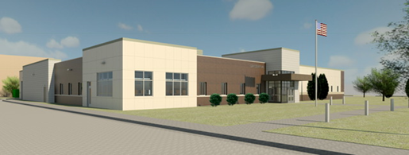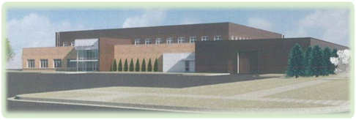
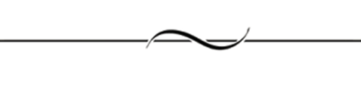
Ceremonial Groundbreaking
Program

May 9, 2017  11:00 a.m.

Presentation of the Colors and Pledge of Allegiance
Sheriff / Police Honor Guard

Emcee / Introductions
Clay County Commissioner Kevin Campbell, Board Chair

Speakers
Commissioner Frank Gross, Behavior Health Committee Chair
Mayor Del Rae Williams, City of Moorhead
Clay County Sheriff Bill Bergquist
Moorhead Chief of Police David Ebinger
Executive Director David Hunstad, Moorhead Business Association
President Craig Whitney, The Chamber–Fargo, Moorhead, West Fargo

Groundbreaking and Photos

Refreshments Served Following Ceremony

